**Chapter 3 Elasticity**

Price Elasticity of demand: the responsiveness of quantity demanded to a change in price of the good or service.

If ED = 0, then demand is perfectly inelastic. It is vertical.

If ED = <1, then demand is inelastic. It is steep.

If ED = 1, then demand is unitary elastic.

If ED = >1, then demand is elastic, it is slightly steep.

If ED = ∞, then demand is perfectly elastic. It is horizontal.

Total revenue/total expenditure on a demand curve: Imagine there is two demand curves. One shows elastic demand, the other showing inelastic demand.

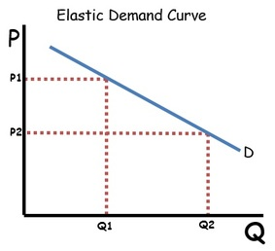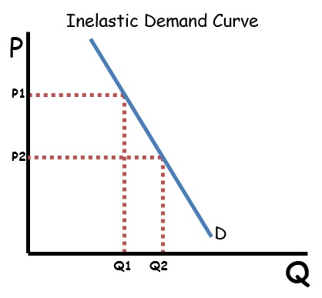

The price moves from P1 to P2 in both graphs by the same amount. The price decreases in these areas by the same amount. The difference in quantity sold (Q1 increasing to Q2) is much larger in the elastic demand curve. It is also an increase. What this means is that a decrease in price will have a larger increase in quantity sold within an elastic demand curve. Therefore it is more profitable to lower the price of an elastic good.

Relationship between price elasticity of demand and total revenue:

* When demand is elastic, they move in different directions.
* When demand is inelastic they move in the same direction.
* When demand is unitary elastic, a change in price does not change total revenue.

The determinants of price elasticity of demand:

* The availability of substitutes. (The more substitutes, the more elastic.)
* Whether the good is a necessity or luxury. (Necessities are inelastic, luxuries are elastic.)
* Definition of the market. (Particular brands are more elastic than a good as a whole.)
* The proportion of income spent. (Cheaper goods are more inelastic than elastic goods.)
* Time. (The more time to respond, the more elastic.)

Elasticity of supply: measures the responsiveness of quantity supplied to a change in price.

Determinants of price elasticity affecting supply:

* Time. (if the producer can respond quickly then supply then supply is price elastic. In the short run inventories are low, therefore supply will be inelastic. As time increases, producers will be able to obtain more inputs and expand output more easily.
* Nature of industry. (Agricultural products are more inelastic, manufactured goods is more elastic. This is because agriculture is time and resource consuming, manufacturing isn’t.)
* Ability to store inventories. (Inventories refer to stocks that a producer keeps stored for future sale. A producer’s ability to store perishable goods makes them more elastic.)

Applications of supply:

When supply is elastic, a change in in demand results in a large shift in quantity sold, but not price. When supply is inelastic, an increase in demand results in a large rise in price but only a small rise in quantity. 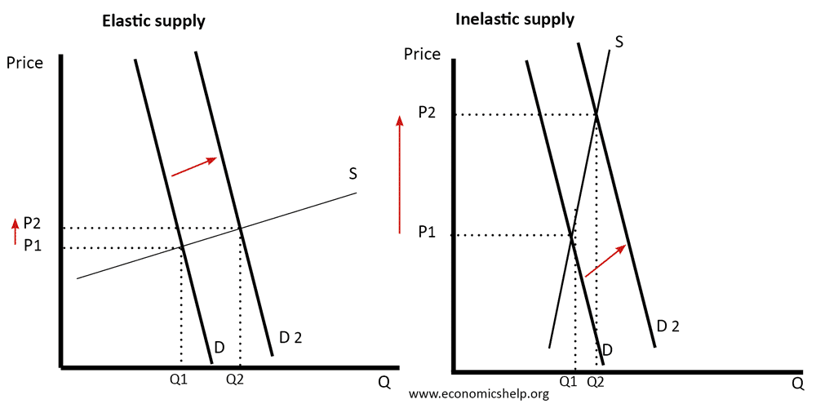

When demand is inelastic, a shift in supply creates a large fall in price, but only a small increase in quantity sold. When demand is elastic, a shift in supply causes a fall in price and a rise in quantity sold.

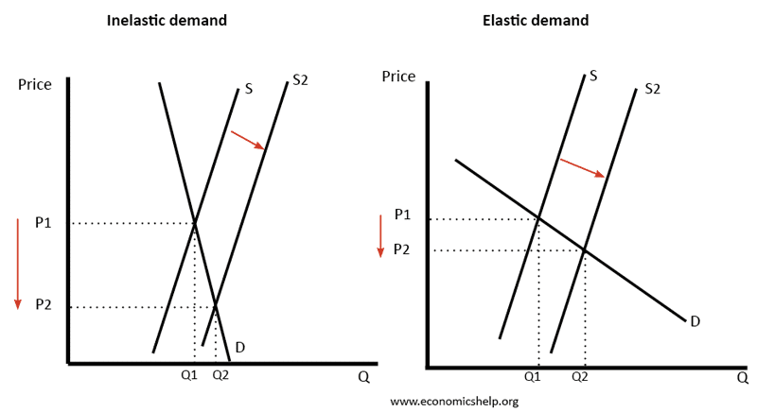

Taxes and elasticity: When a tax is placed on a good, it creates a wedge between prices payed by consumers and the price received by producers. A tax will increase the amount paid by consumers, decrease the price received by producers and decrease the quantity sold. Excise taxes are directed at goods with inelastic demand. Taxes on inelastic products are effective in raising revenue and they have marginal impact on quantity sold.

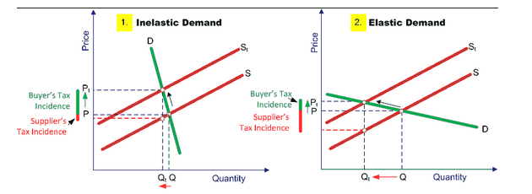

Both the incidence of the tax and the amount of tax revenue is determined by price elasticity:

* The incidence or burden of a tax will fall more on the consumer when demand is relatively inelastic compared with supply (or fall more on the producer when demand is relatively elastic compared with supply).
* Tax revenue will be greater on goods with inelastic demand.